CS669 Final Project:

Health Option.
Anthony Cassetta

Table of Contents

Table of Contents
Business Rules | Page 3
Business Constraints | Page 3
Conceptual ERD | Page 4
Logical ERD | Page 5
Use-case Screenshots | Page 7
Notes | Page 16

Business rules:
A Facility has many buildings; A Building must belong to one and only one Facility.
A Building may have many Physicians practicing from them; A Physician may only practice out of one Building.
A Facility may accept many Insurance plans; An Insurance plan may be accepted at many facilities.
An Insurance plan may have many Bills; A bill may go to only one Insurance Plan.
A Patient may have many visits with many Physicians; A Physician may have many visits with many Patients.
A physician must have one or more Specialties; A Specialty may apply to one or more Physician.
Every Appointment creates one and only one Bill; A Bill belongs to one and only one Appointment.

Business Constraints:
A Physician will have a documented maximum capacity for Appointments per-day, exceptions can be made to go over that limit.
If a Physician visit is canceled, The first Patient on that Physicians the waitlist will scheduled a visit, then that patient will be removed from the Waitlist.
A Patient and Physician combination may appear on the Waitlist once; The Waitlist may have many Patient and physician combinations listed.
balance on Patient table will be a Trigger controlled value. When a Bill is created the trigger will take copay_amt minus Copay_paid. Then add this new value to the patient's current balance.
Combination on the Waitlist once an appointment is made the combination will then be removed from the Waitlist.
When an existing Appointment is canceled it shall be replaced by the first Patient and Physician combination on the Waitlist once an appointment is made the combination will then be removed from the Waitlist.

Conceptual ERD: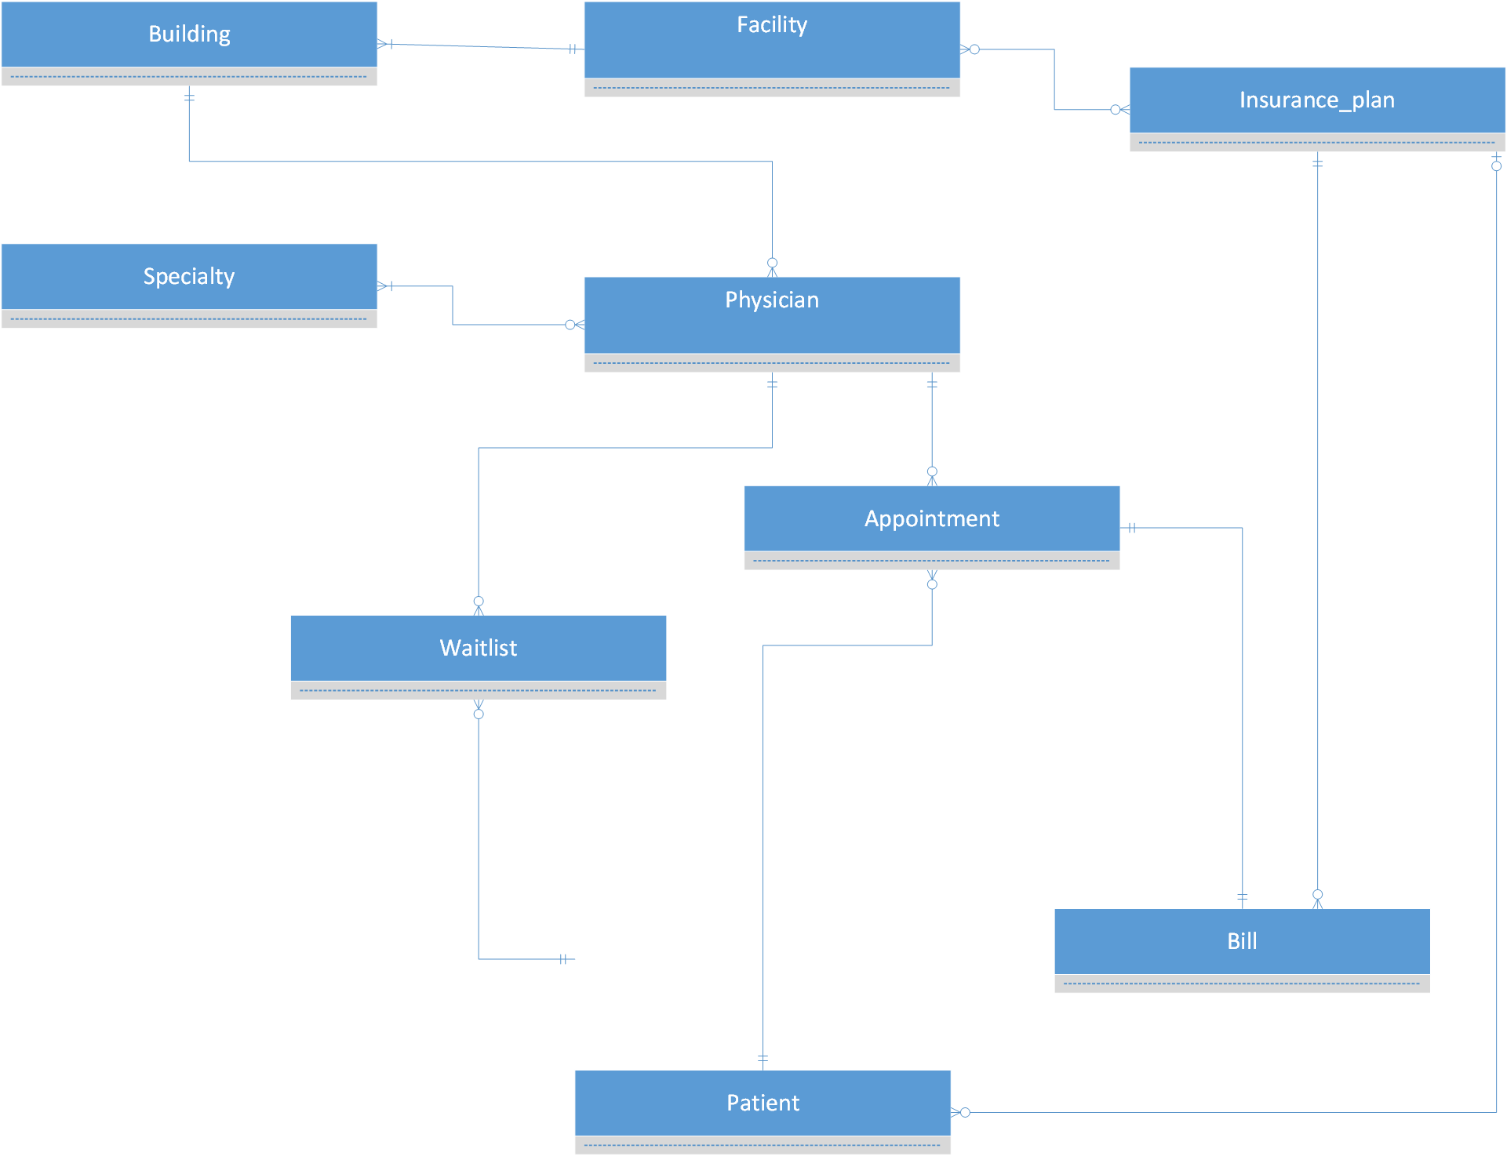

LOGICAL ERD:
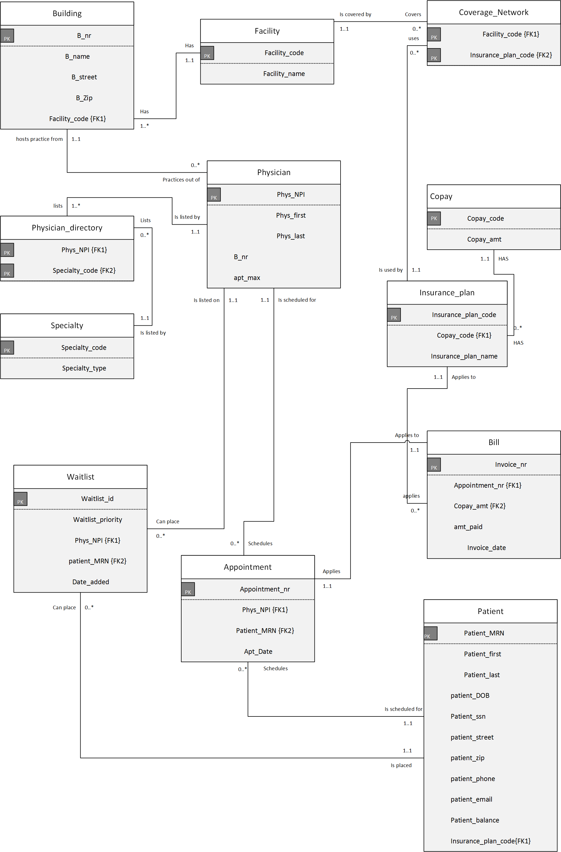

Screenshots illustrating execution & results of the SQL addressing the 10 USE CASES:
1.
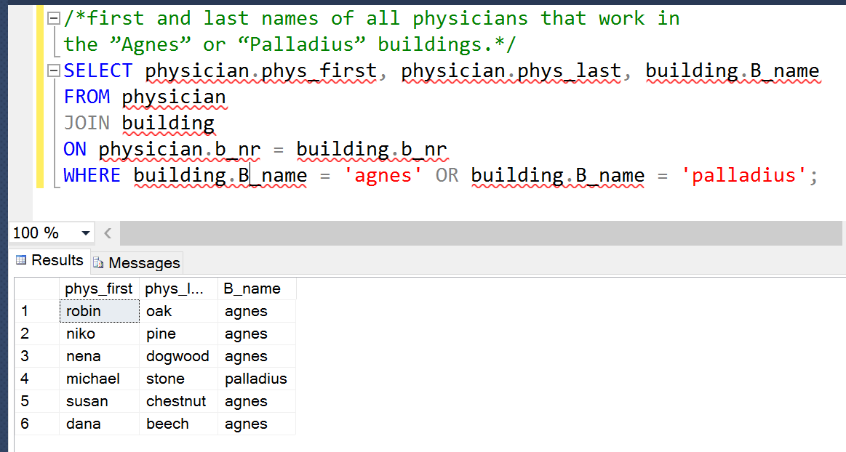
2.
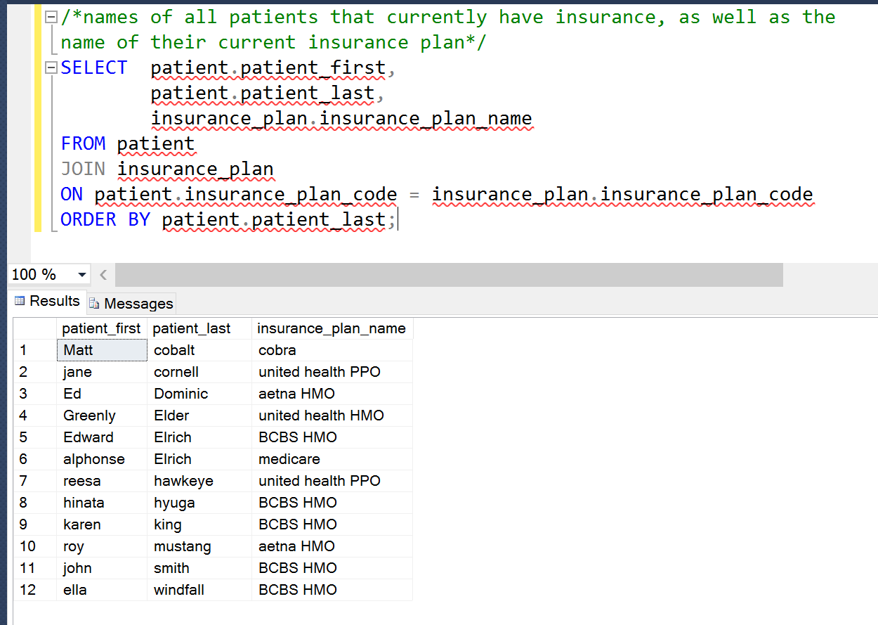

3.
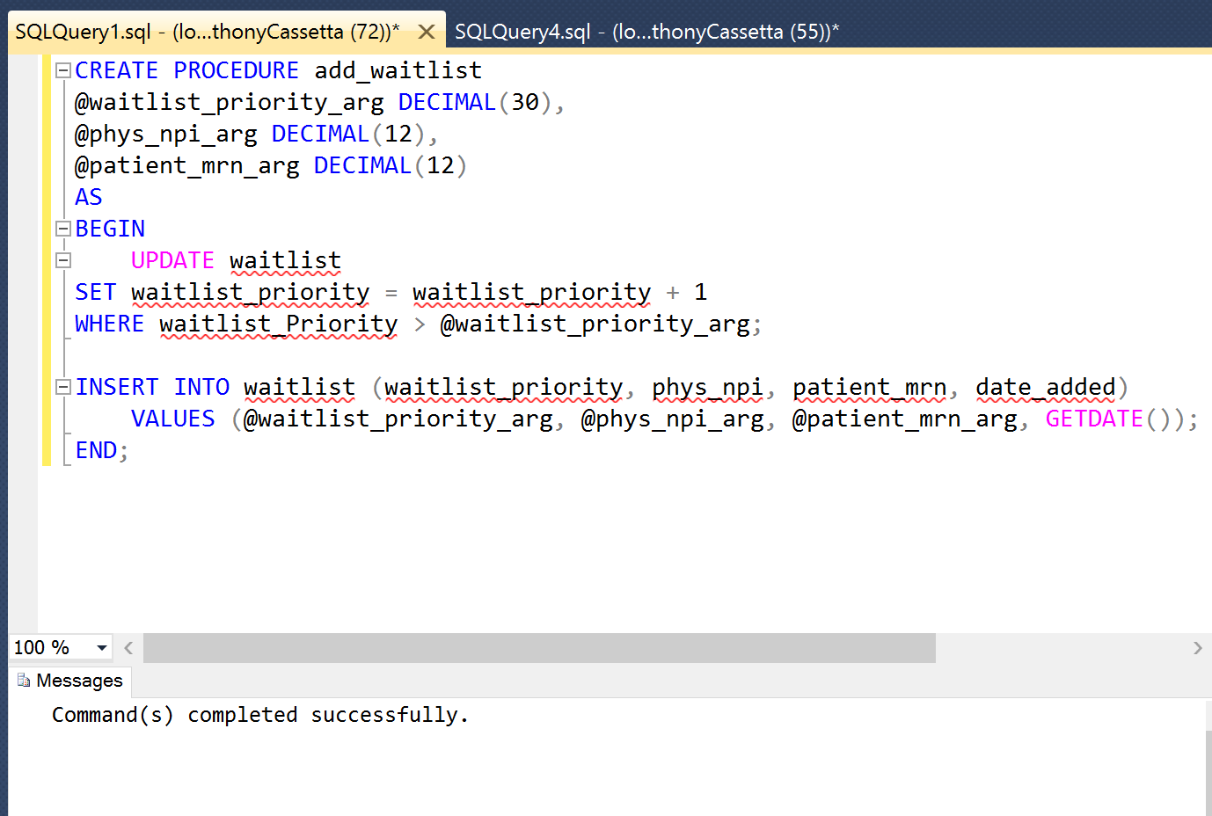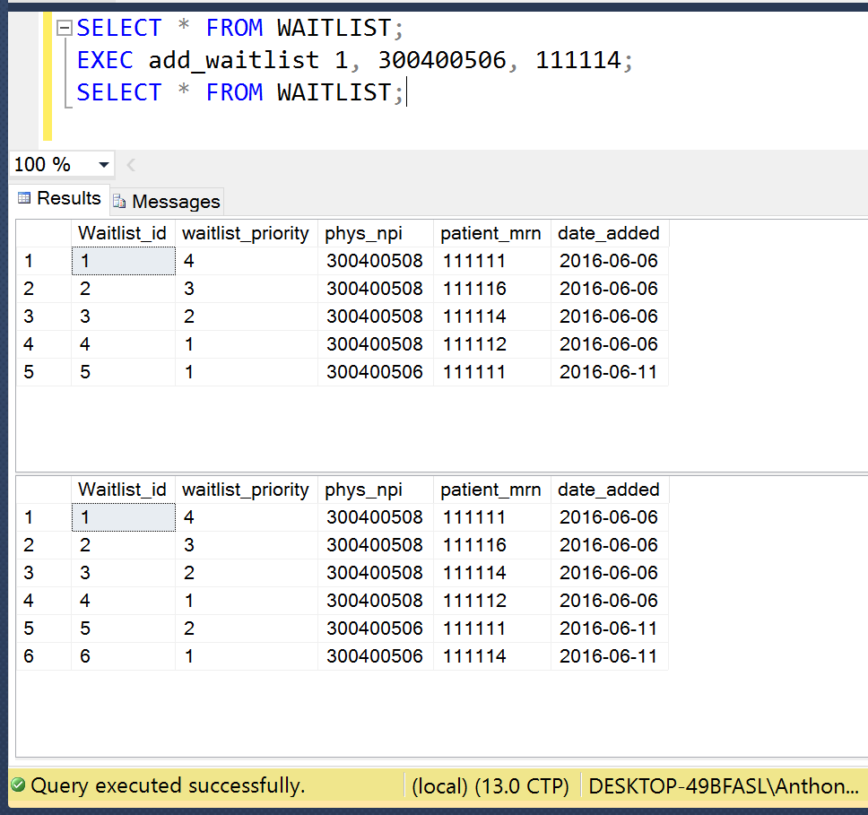

4.
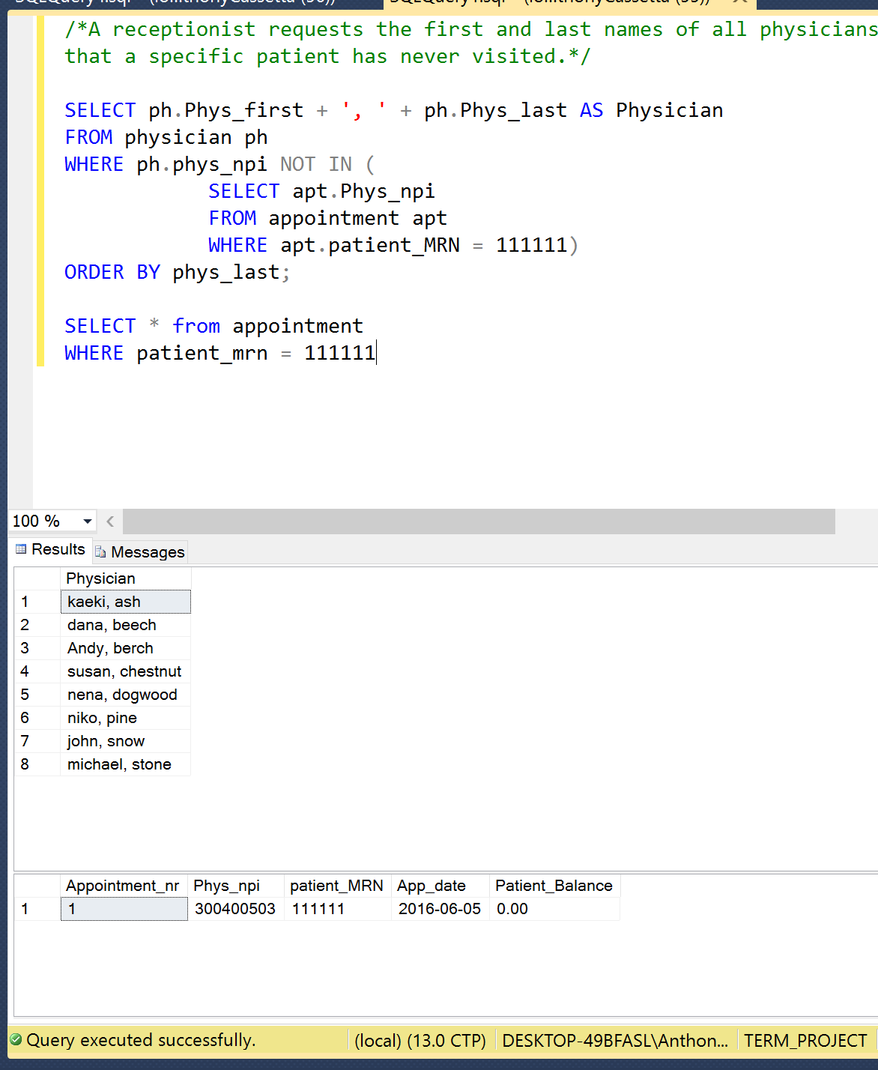

5.
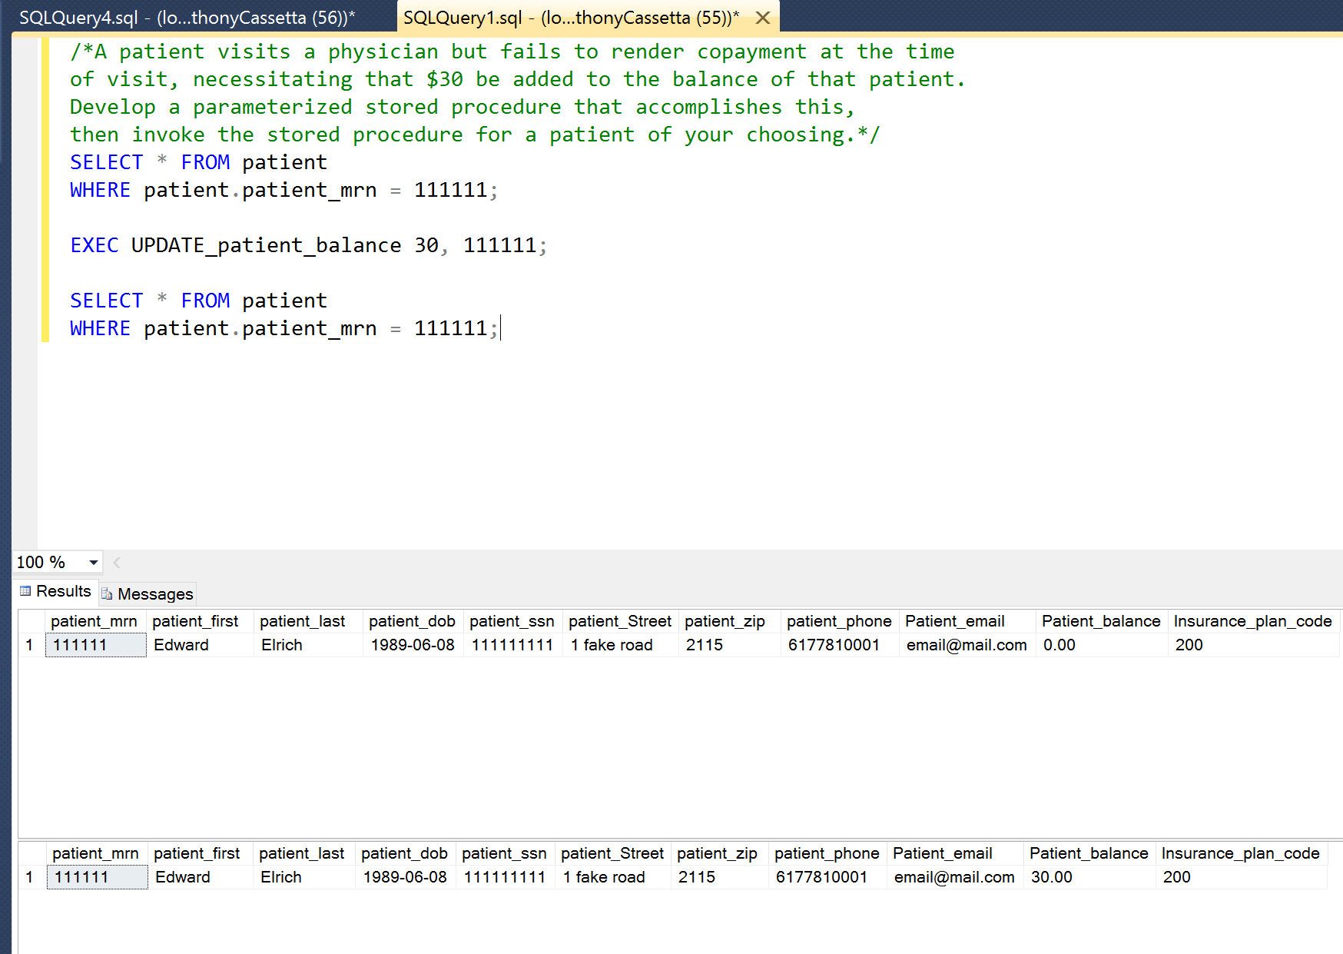

6.
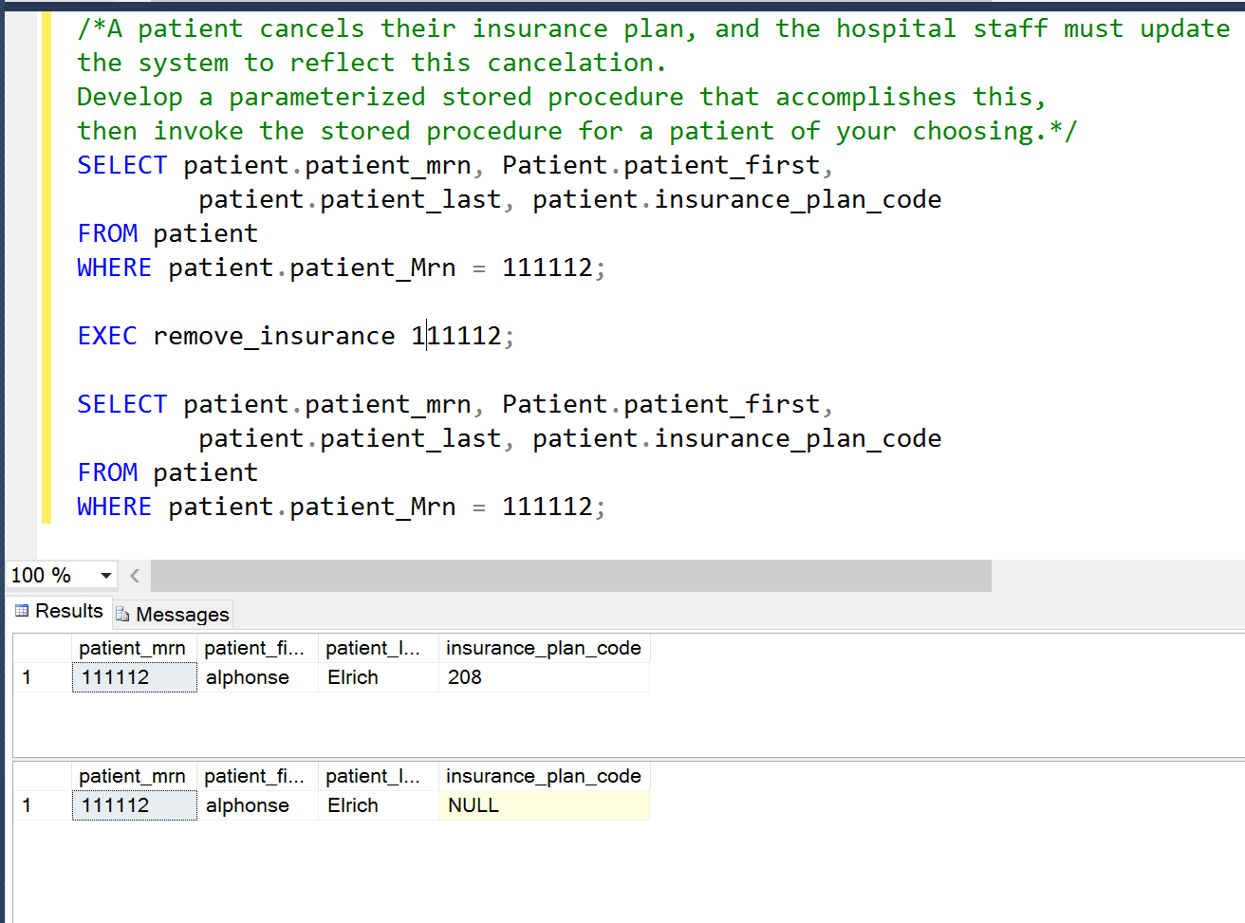

7.
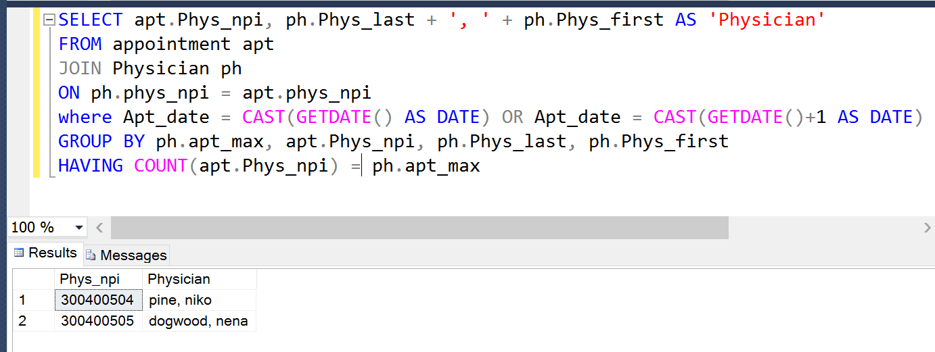

8.
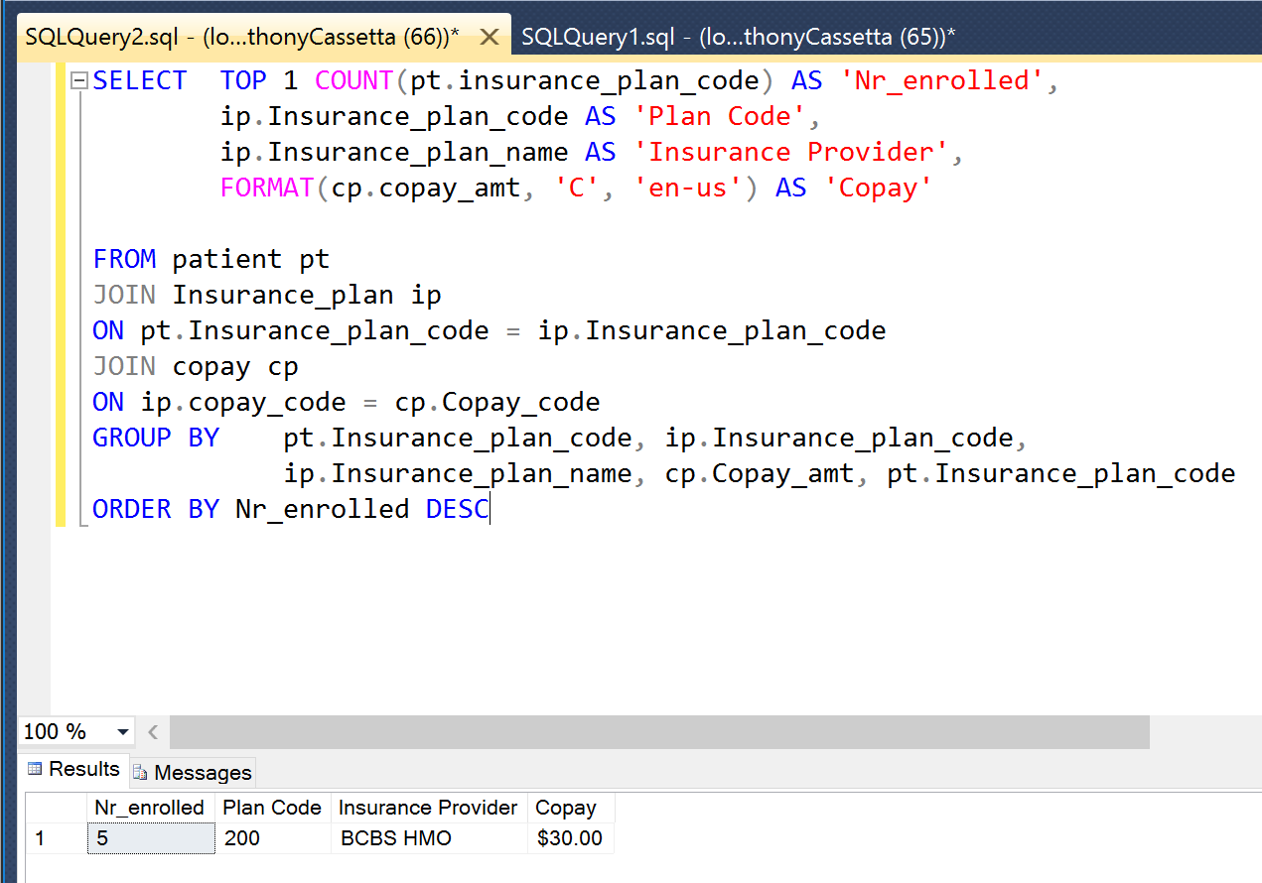

9.
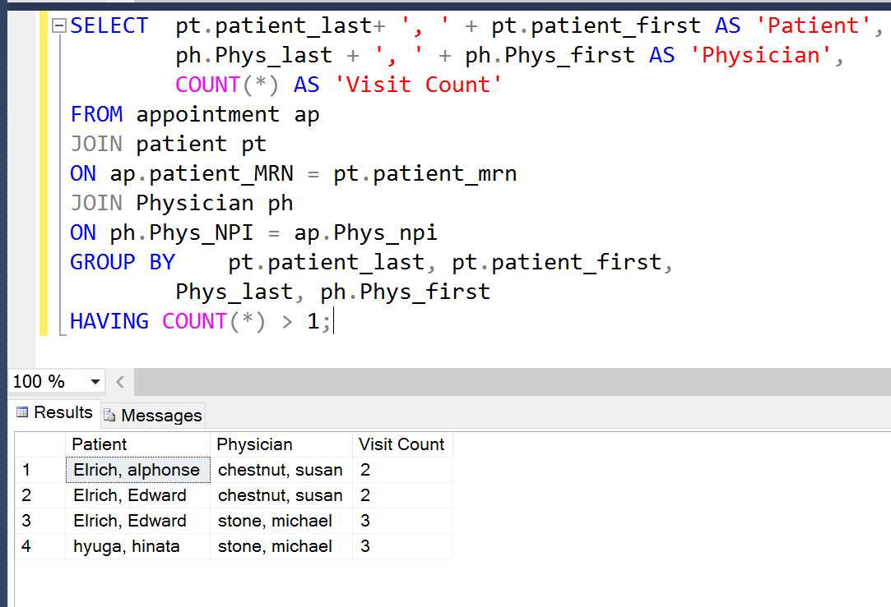

10.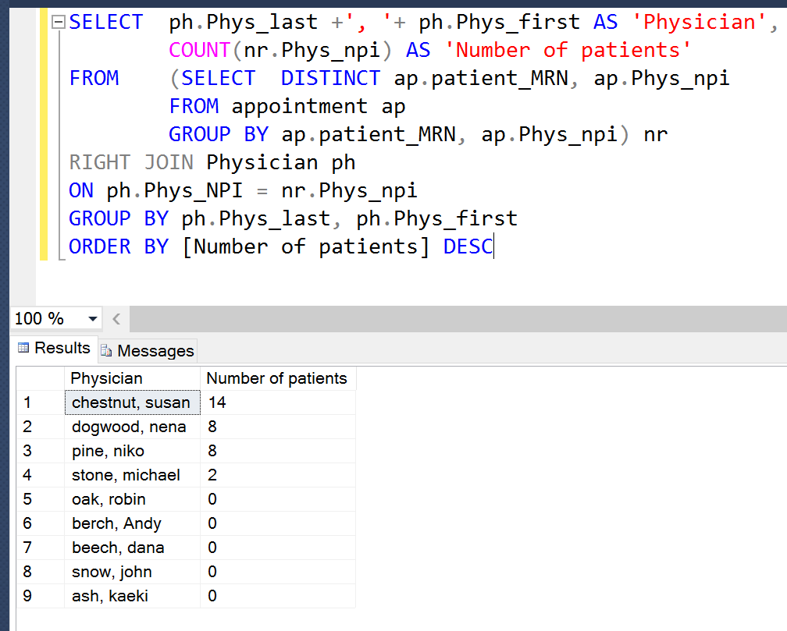

Screenshots illustrating the creation of two indexes, along with explanations:

Index 1.
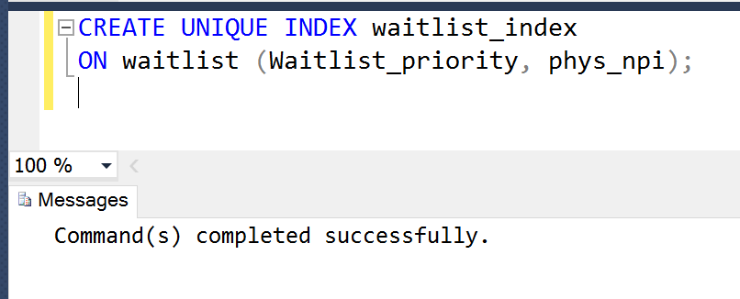
With the assumption that this database would be used at a much larger scale than just this project, this index would serve to efficiently allow searching through the waitlist based on the Physician a requestor would need information from. This index also enforces a uniqueness constraint that will prevent any physician from having multiple patients with the same priority level. It is unnecessary to create in indexes on the waitlist table in regard to patients as the business constraints say that a patient should only be listed at most once, for each physician.

Index 2.
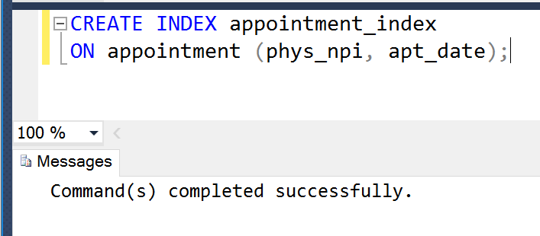
With the same assumptions about scale as above, an index on the appointment table would expedite searching for available visits, or searching for existing appointments by date and provider ignorer to update or delete that appointment.
A similar index for patient and appointment date would also benefit the table, as Searching by physician or patient are the most likely queries.

Notes:
Primary key naming convention (pk_table name)
Foreign key naming convention (host table name_fk)
Priority scale highest 1, priority lowers as number gets greater.
Were this a production instillation I would have built a trigger to create a bill which would automatically fire when an insert was performed on appointment.

